## **Language Learning AI Game PRD**

## **Introduction**

This Product Requirement Document (PRD) outlines the requirements for the Language Learning AI Game, a comprehensive platform designed to revolutionise language learning through immersive AI-driven experiences. This PRD will detail the purpose, features, key objectives, assumptions, user personas, and unique features of the game. It will also outline the core UX flow, success metrics, and roadmap of the product, aiming to provide a dynamic and engaging learning environment for users worldwide.

## **Table of Contents**

1. Product Vision
2. Background
3. Problem statement
4. Goals/Objectives
5. Assumptions/Hypotheses
6. User Personas
7. Key Features/Functionalities
8. Core UX flow
9. Success Metrics
10. Roadmap

## **Product Vision**

To create an engaging, immersive, and personalised language learning experience through a 3D interactive game, leveraging advanced AI technology to make language acquisition fun, effective, and accessible for users of all ages and backgrounds.

## **Background**

The language learning industry is experiencing rapid growth due to globalisation and increased travel. While traditional methods like textbooks and classroom instruction are still in use, online learning platforms have become increasingly popular because of their flexibility and affordability. However, these digital platforms often struggle with personalization and user engagement. Driven by the growing importance of bilingualism in professional settings and the convenience of digital platforms, the industry is set to expand even further. Technological advancements, such as AI and VR, are expected to play a key role in enhancing the language learning experience, making it more personalised and immersive for users.

Language Learning Key Benefits for Users

* Personalised Learning Experience: The product is designed to provide AI-driven content that adapts to the user's progress, offering customised lessons and challenges.
* 24/7 Accessibility: Users can learn anytime, anywhere, with an AI companion that adjusts to their busy schedules.
* Interactive and Engaging Learning: Users will experience fun and engaging learning through immersive 3D graphics, dramatic storylines, real-life scenarios, and interactive activities enhanced by dynamic AI-driven 3D characters.
* Intelligent Feedback: There will be a personalised review and pronunciation feedback section that will help users improve in specific areas, ensuring a comprehensive and effective learning experience.

Importance of our Solution

The product transforms language learning into an immersive, engaging experience through interactive 3D environments and storytelling. It emphasises practical application by simulating real-life scenarios, while personalised lessons tailored to individual learning styles and progress enhance retention and learning outcomes. Our innovative use of cutting-edge technology ensures a modern solution that meets the evolving needs of language learners worldwide.

## **Problem Statement**

Many traditional language learning methods struggle to keep users engaged. They can be repetitive, lack real-world context, and fail to capture the excitement of using a new language in everyday situations. The Language Learning AI Game addresses this challenge by creating an immersive 3D environment. Here, users can practise their language skills in engaging, real-life scenarios. This approach promotes practical language application and makes learning both fun and effective.

## **Goals/Objectives**

By building this product, the aim is to create an AI-driven language-learning platform that will deliver an immersive, personalised, engaging, and effective learning experience for users.

The primary goal of the Language Learning AI Game is to facilitate language learning through interactive gameplay by:

1. Utilising AI to personalise the learning experience.
2. Providing a fun and engaging platform for users to practise language skills.
3. Incorporating dramatic storylines to engage users and keep them interested.

## **Assumptions/Hypothesis**

Assumption 1: Users are more likely to be engaged and motivated by a fun and interactive learning experience compared to existing methods.

Hypothesis: *Including gamification features, 3D visuals, and emphasising speech can improve user engagement and retention.*

Assumption 2: AI is able to accurately provide feedback on grammar and pronunciation, adjust learning paths based on user success, and personalise them.

Hypothesis: *Improved communication skills and a quicker rate of language acquisition are two benefits of using AI for learning.*

Assumption 3: Compared to conventional drills and exercises, immersing users in simulated conversations and settings will be more helpful for improving speaking and listening abilities.

Hypothesis: *The game's increased AI-enhanced natural language exchanges will greatly increase speaking fluency and comprehension*.

## 

## **User Personas**

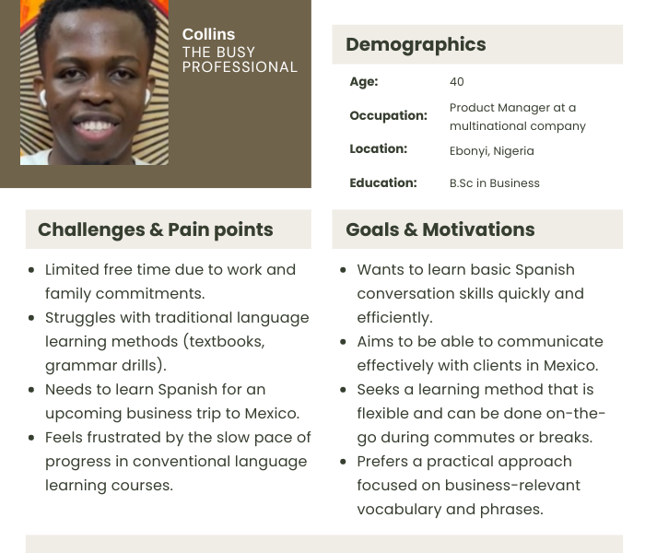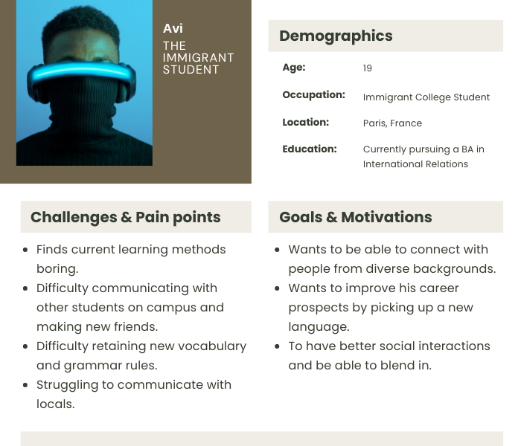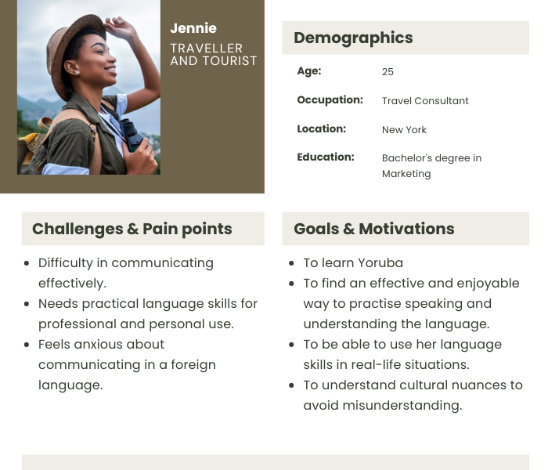

## **Key Features/Functionalities**

1. Interactive Dialogues with 3D Avatars: For users to practise language skills in context.

| User Story | Acceptance Criteria |
| --- | --- |
| As a learner, I want to be able to evaluate my speaking skills, so that I can assess my level of language proficiency. | 1. The system allows users to have interactive conversations with avatars. 2. Learners receive immediate feedback on their speaking skills. 3. Speaking evaluations will focus on pronunciation, fluency, and accuracy. 4. Progress in speaking skills is tracked and displayed. |
| As a learner, I want to receive corrections on grammatical mistakes and suggestions for better ways to phrase sentences during conversations with avatars so that I can learn from my errors and improve quickly. | The system provides real-time corrections during avatar conversations.  Learners receive suggestions for better phrasing.  Feedback includes explanations for grammatical corrections.  The system tracks common errors and shows progress over time. |

2. Dramatic Storylines: To make learning fun by immersing users with exciting, memorable stories to aid retention.

| User Story | Acceptance Criterion |
| --- | --- |
| As a learner, I want to be immersed in a story that challenges me to think creatively so that I can improve my language learning skills. | 1. The story includes challenging scenarios that require creative thinking. 2. Learners receive feedback on their problem-solving approaches. 3. Progress through the story is tracked and displayed. |
| As a learner, I want to choose a quest type, like adventure, mystery, or romance, so that I can tailor my language learning experience to my interests and stay motivated. | 1. The system offers various quest types for selection. 2. Each quest type has unique storylines and language tasks. |
| As a user, I want to meet interesting characters, so that I can build relationships with them. | 1. The story includes a variety of interesting characters. 2. Learners can interact with characters and build relationships. 3. Character interactions influence the storyline and outcomes. |
| As a user, I want to interact with characters who have hidden agendas, so that I can use my language skills to understand their true intentions and win challenges. | 1. Some characters have hidden agendas that affect interactions. 2. Learners receive clues and feedback based on their language skills. 3. Successfully uncovering hidden agendas leads to rewards or progression in the story. |
| As a learner, I want to go on a journey filled with emotions like love, betrayal, satisfaction and happiness so that I can have a more immersive and engaging experience. | 1. The story includes emotional and dramatic events. 2. Learners receive feedback on their responses to emotional scenarios. 3. Emotional events influence the storyline and character relationship. |
| As a learner, I want cultural insights and idiomatic expressions explained in context, so I can better understand the nuances of the language. | 1. The story includes cultural insights and idiomatic expressions. 2. Learners receive explanations and context for cultural and idiomatic elements. 3. Progress in understanding cultural and idiomatic expressions is tracked. |

3. AI-Powered Speech Recognition: To enhance conversations with avatars and provide immediate feedback on pronunciation, helping users improve their language skills faster.

| User Story | Acceptance Criteria |
| --- | --- |
| As a learner, I want to be able to practise basic vocabulary and pronunciation so that I can build my fluency. | 1. Accuracy of speech recognition is maintained at 98% or higher for beginner-level vocabulary. 2. The system offers immediate feedback on pronunciation accuracy. 3. The system provides pronunciation guides (audio or visual) for each word. 4. Learners can record and playback their pronunciation attempts. |
| As a language learner, I want suggestions on how to improve my grammar so I can learn from my mistakes. | 1. 5The system can identify common grammatical errors in learners' inputs. 2. Learners receive real-time grammar correction suggestions. 3. Grammar corrections are clear and easy to understand. 4. Learners can review a summary of their grammatical errors and corrections. 5. The system provides practice exercises focused on areas where learners commonly make mistakes. |

4. Adaptive Learning pathway: To adjust learning content according to the specific needs and proficiency of the learner

| User Stories | Acceptance Criteria |
| --- | --- |
| As a learner, I want to take an initial assessment to see how proficient I am in a language so the game can adjust its difficulty accordingly. | 1. The initial assessment should include all core language abilities (listening, and speaking) at varied levels of difficulty. 2. Learners receive a proficiency score and level after completing the assessment. 3. The game difficulty adjusts based on the learner's proficiency level. 4. Learners receive feedback on their performance in the assessment. |
| As a learner, I want the system to provide me with additional practice exercises when I struggle with a specific word. | 1. The system identifies words that learners struggle with. 2. Learners receive targeted practice exercises for flagged words. 3. The system tracks progress on previously flagged words. |
| As a learner, I want the difficulty of my learning exercises to adjust automatically based on my performance. | 1. The system dynamically adjusts the difficulty of exercises based on learner performance. 2. Learners receive immediate feedback on their performance. 3. The system provides notifications or indicators when the difficulty level changes. |
| As a learner, I would like to receive personalised learning tasks that target my specific weaknesses and learning goals. | 1. The system should keep track of the learner's specific learning goals and weaknesses. 2. The system generates personalised learning tasks based on this. 3. Learners receive regular updates on their progress towards their learning goals. |
| As a learner, I want to be able to set my own learning goals, such as focusing on a specific area of vocabulary or improving my conversational fluency. | 1. Learners can set specific, measurable learning goals within the system. 2. The system offers suggestions for achievable goals based on the learner's proficiency level. 3. Learners receive customised learning activities aligned with their goals. 4. The system tracks progress towards each goal and provides regular updates. |

5. Progress Tracking: To track the user’s improvement over time.

| User Story | Acceptance Criteria |
| --- | --- |
| As a user, I want a tracking feature that includes reminders and notifications for practice tasks to help me maintain consistency in my learning routine. | 1. The system sends reminders and notifications for scheduled language learning sessions and tasks. 2. Users can customise notification settings, including frequency and type. 3. The system alerts users about upcoming challenges and activities. 4. Notification history is accessible for users to review past reminders. |
| As a user I want to see charts, and badges that show my learning progress. | 1. The system displays progress charts for different language tasks. 2. Users earn achievement badges for reaching specific milestones. 3. The system celebrates milestones with animations. 4. Progress visuals are easily accessible from the user dashboard. |
| As a user, I want to track my daily learning activities, such as completed lessons and learned vocabulary. | 1. The system logs daily language learning activities, including lessons, vocabulary, and grammar exercises. 2. Users can view a summary of their daily activities. 3. The system highlights key accomplishments and areas for improvement. 4. Activity tracking is accessible from the user dashboard. |

6. Personalised Assistance: To give suggestions and memory aids for improving performance, and correcting errors.

| User Story | Acceptance Criteria |
| --- | --- |
| As a learner, I want to receive personalised grammar hints and exercises based on my frequent mistakes, so that I can improve my accuracy and fluency more effectively. | 1. The system identifies frequent grammar mistakes made by the learner. 2. Personalised grammar hints and exercises are generated based on these mistakes. |

8. Gamification: To enhance the learning experience by making it more engaging through challenges and rewards.

| User Story | Acceptance Criteria |
| --- | --- |
| As a learner, I want to earn points for completing tasks, so that I feel motivated to participate in more learning exercises. | 1. Points are awarded for completing language learning tasks. 2. The points system is clearly explained to learners. 3. Learners can view their total points and progress towards goals. |
| As a learner, I want to unlock badges for achieving milestones, allowing me to showcase my accomplishments and milestones. | 1. Badges are awarded for specific achievements and milestones. 2. The criteria for earning badges are clearly explained. 3. Notifications are sent when badges are earned. |
| As a learner, I want to see a leaderboard displaying fellow learners based on points earned that week, so that I can compare my progress with others and stay motivated. | 1. A leaderboard should display the list of top learners based on points earned weekly. 2. Learners can view their position on the leaderboard. 3. The leaderboard is updated in real-time or at regular intervals. 4. Notifications are sent for changes in leaderboard positions. |
| As a learner, I want to participate in challenges with other learners, as it will help me improve my language skills through competition and collaboration. | 1. Challenges are available for learners to join. 2. Challenges can be individual or team-based. 3. Progress in challenges is tracked and displayed. 4. Rewards or points are given for completing challenges. |
| As a learner, I want to share my learning accomplishments with friends on social media, so that I can celebrate my progress. | 1. Learners can share achievements, badges, and progress on social media platforms. 2. The sharing process is straightforward and user-friendly. 3. Customizable messages are available for sharing. 4. Learners receive feedback or recognition for shared accomplishments. |

## 

## Core UX Flow

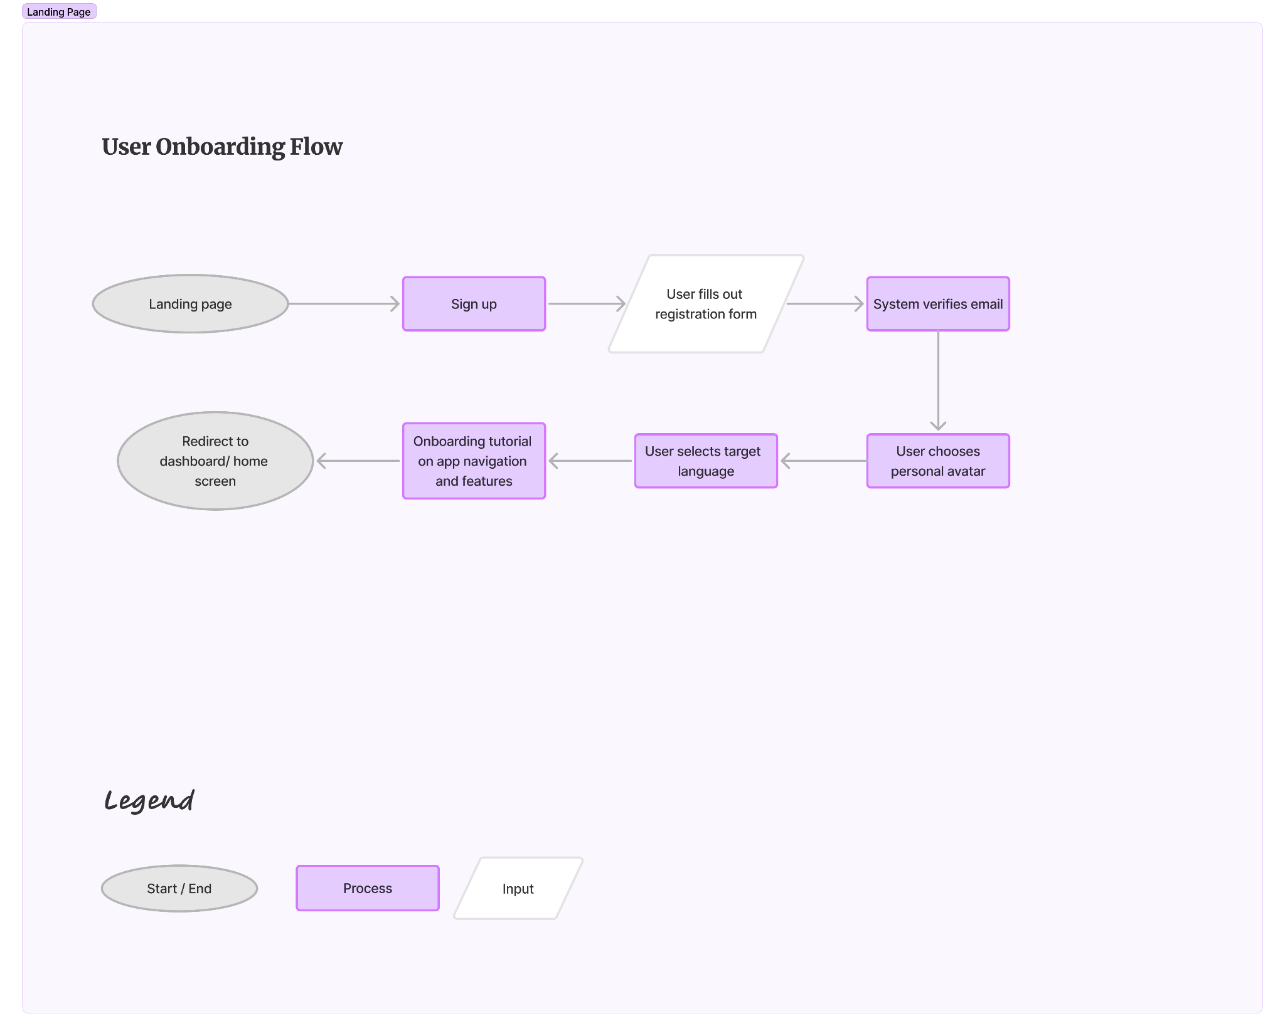

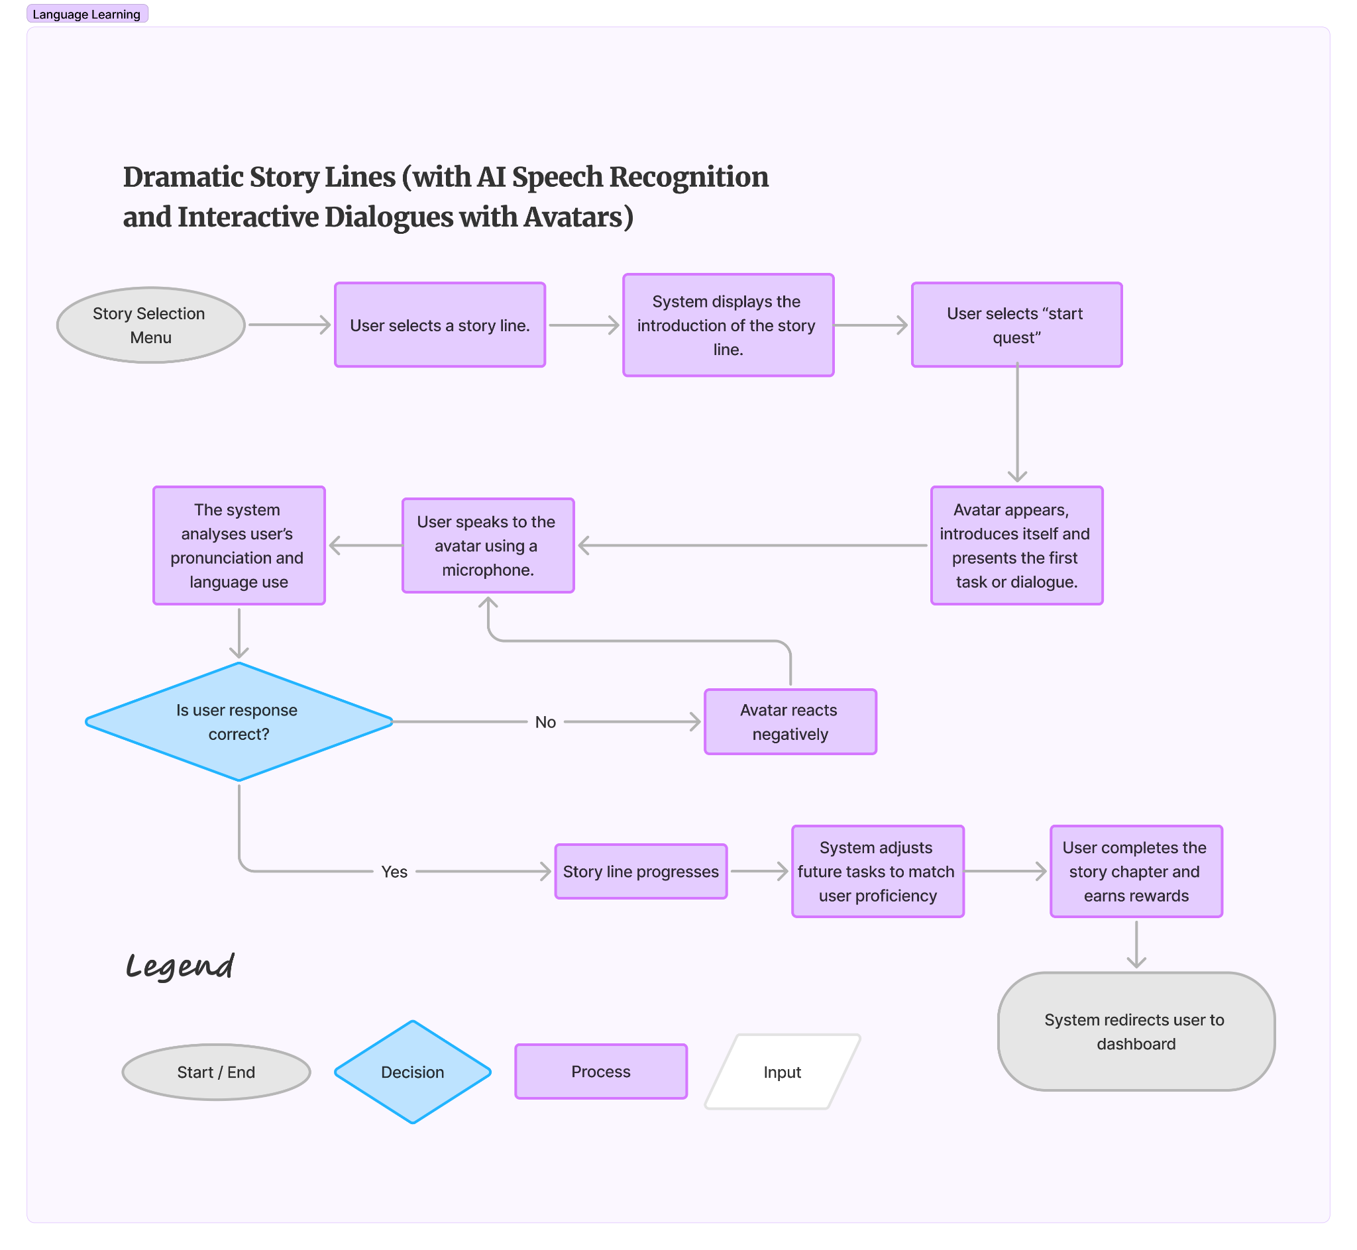

## 

## **Success Metrics**

* User Behavior and Engagement:
  + Active users: to track the daily active users (DAU) and monthly active users (MAU).
  + Average Session Duration: The average amount of time users spend on the platform per session.
  + Total Learning Time: The cumulative amount of time users spend on the platform.
  + Features usage: Analyse how often users interact with specific features like gamification elements, avatar customization, or the AI guide.
  + Progress Tracking: To measure users' progress and achievement within the game.
  + Pronunciation Improvement: Utilise the speech recognition features to track improvements in pronunciation accuracy based on AI's feedback.
  + Tasks Completion Rate: The percentage of users who successfully complete a task.
* User Satisfaction
  + App Ratings and reviews: Monitor user reviews and ratings on app stores to gather direct feedback on user experience and satisfaction.
  + Net promoter score: Measure the likelihood of customers to recommend the product to others. Achieve a 10% NPS score within the first 6 months after launch
* User Retention
  + User Drop-off rates: Monitor the percentage of users who stop using the app after a certain period.
  + Session Frequency: Analyse how often users return to the app for repeat sessions.
  + Churn Rate: To measure the percentage of customers who stop using the app within a certain period of time.
  + Conversion Rate; to track the percentage of visitors to the app's landing page, advertisement, or other touchpoint who eventually convert into actual users by downloading and signing up for the app.